Anglo-Saxons and Scots Worksheet
QUESTION 1
Answer the following true or false questions by circling an answer for each one.

- Europe made a lot of progress during the Dark Ages.

TRUE FALSE

- Britain was left in a weak position when the Roman Army stopped protecting it.

TRUE FALSE

- It is difficult for us to know what was going on during the Dark Ages, because there weren’t many people recording its events.

TRUE FALSE

QUESTION 2
In the table below, sort the new Anglo-Saxon kingdoms (shown in the boxes) into the three headings of ‘Angles’, ‘Saxons’, and ‘Jutes’, based on which tribes they originated from.

Wessex
Essex
Cantaware
Middlesex
Northumbria
Mercia
East Anglia
Sussex

Angles | Saxons | Jutes

QUESTION 3
Look at the drawing of the Anglo-Saxon below. Do you think that he looks more like a poor person or more like a king? Explain your decision.

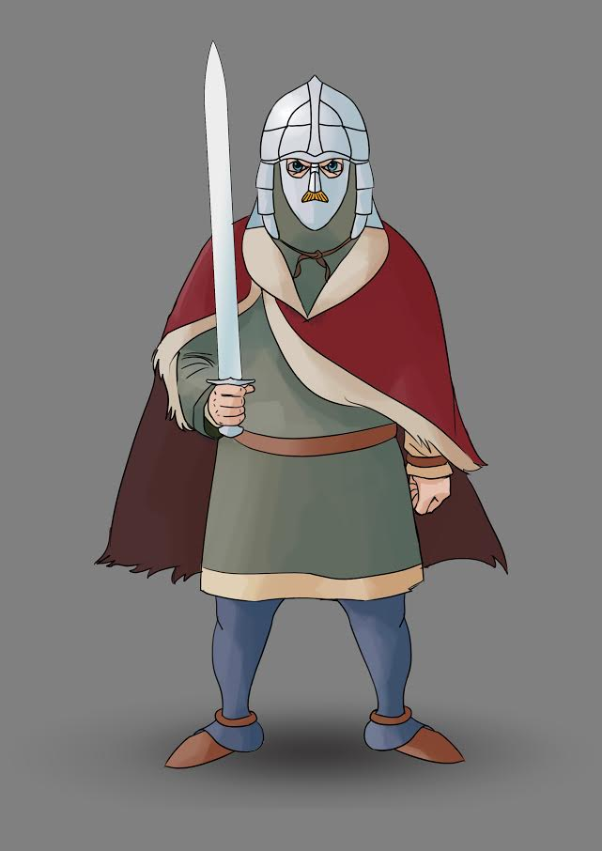

__________________________________________________________________________________

__________________________________________________________________________________

__________________________________________________________________________________

__________________________________________________________________________________

QUESTION 4
Using the words in the box below, fill the gaps in the paragraph underneath. Only use each word once!

mead
writing
crafting
warriors
epic

Anglo-Saxons were great at ____________________, making jewellery and decorating weapons. In a similarly creative vein, Anglo-Saxons loved to tell stories. This would both be done in ____________________, and through spoken word. Storytelling would take place in Great Halls, where bards would tell ____________________ stories of great ____________________. Listeners would enjoy such tales over a drink of ____________________ or two!

QUESTION 5
Using the bullet points below, write down three things that Anglo-Saxon children would do instead of going to school:

- ______________________________________________________________________

- ______________________________________________________________________

- ______________________________________________________________________

ANSWERS

QUESTION 1
The statements should have been circled as follows:

- Europe made a lot of progress during the Dark Ages.

TRUE FALSE

- Britain was left in a weak position when the Roman Army stopped protecting it.

TRUE FALSE

- It is difficult for us to know what was going on during the Dark Ages, because there weren’t many people recording its events.

TRUE FALSE

QUESTION 2
The tribes should have been sorted as follows:

Angles | Saxons | Jutes
East Anglia | Essex | Cantaware
Mercia | Middlesex
Northumbria | Sussex
 | Wessex

(Note how the Angles’ tribes end in ‘ia’ and the Saxons’ tribes end in ‘sex’.)

QUESTION 3
(Below is an example of how the Anglo-Saxon in the picture could be described. You got the right answer if you said that he looks more like a king – because of his belongings.)

The Anglo-Saxon in the drawing looks more like a king than a poor person. This is due to the fact that he is holding a large and impressive sword, and wearing a decorative helmet. These items were expensive to make, so while being useful items in their own right, they were definitely status symbols as well.

QUESTION 4
The gaps should have been filled as follows:

Anglo-Saxons were great at crafting, making jewellery and decorating weapons. In a similarly creative vein, Anglo-Saxons loved to tell stories. This would both be done in writing, and through spoken word. Storytelling would take place in Great Halls, where bards would tell epic stories of great warriors. Listeners would enjoy such tales over a drink of mead or two!

QUESTION 5
Three things that Anglo-Saxon children did instead of going to school:

- Herd cattle;
- Plant vegetables;
- Look out for wolves.

You may be interested in our KS2 History is Easy Revision guide and mock test workbook:

