French GCSE Revision – ‘the Internet’ – Key Vocab
As in English, hundreds of new words surrounding the internet and social media spring up in French each year. Many of them are derived from or identical to their English equivalents, but, as you will discover below, many of them are unrecognisable when placed next to their translations. This can make French GCSE revision and its internet topic tricky to revise for.
So, as the influence of the internet and social media becomes more and more apparent in our lives, the French GCSE revision topics of ‘the Internet’ and ‘New Technology’ will become more and more important, as this subject will appear with more and more frequency in exams. So, becoming familiar with vocabulary surrounding Twitter and its use can only serve to benefit your studies, and will help your real-world application of French as well. And, who knows, in the coming years, examiners might finally realise that there are other forms of online communication and stop setting every reading exam question as: ‘Read this email from your friend…’

Un tweet !
See below for vocab surrounding a tweet itself:
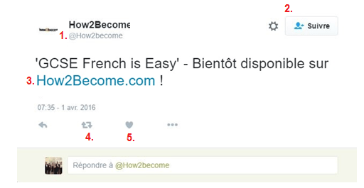

- Un compte twitter/pseudo – A twitter account/username
- Le bouton ‘suivre’ – The ‘follow’ button
- Un lien partagé – A link that has been shared
- Retweeter – Retweet
- Aimer – Like

Un profil de Twitter – A twitter profile
See below for vocab surrounding twitter profiles:

  - Le bouton d’accueil – The home button
  - Faire un tweet/Tweeter – Post a tweet/Tweet
  - La photo de bannière – Header photo
  - La photo de profil – Profile photo
  - Abonnements – Following
  - Abonnés – Followers
  - Aimés – Liked (tweets)
  - Éditer le profil/Paramètres – Edit profile/Settings
  - Localisation – Location
  - Le Site Web – Website

Le journal – Timeline
See below for vocab surrounding timelines:

    - Quoi de neuf ? – What’s happening?
    - Ajouter une photo ou video – Add photos or video
    - Répondre – Reply
    - Un retweet – A retweet
    - Le hashtag – hashtag
    - Mettre une photo sur twitter – To post a photo on twitter

Un message privé – A direct message
See below for vocab surrounding direct messages:
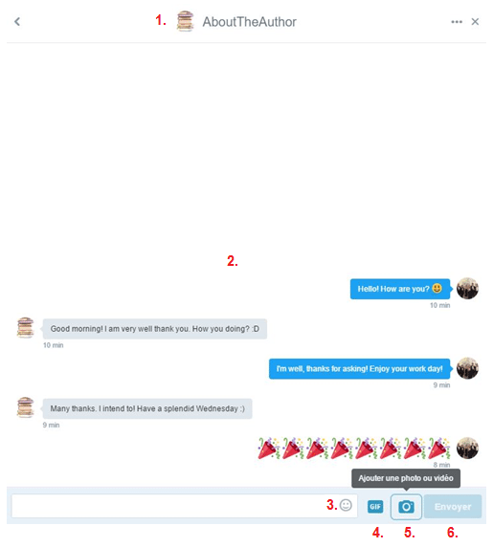

      - Destinataire – Recipient
      - La conversation – The conversation
      - Les émoticônes/emoji – Emoticons/emoji
      - Ajouter un GIF – Add a GIF
      - Ajouter une photo ou video – Add photos or video
      - Envoyer – Send

Tendances – Trends
See below for vocab surrounding trending topics:
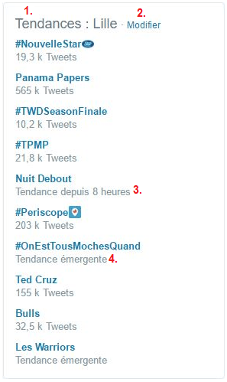

        - Tendances – Trending topics
        - Modifier – Change (options for displaying trends)
        - Tendances depuis 8 heures – Trending for 8 hours now
        - Tendance émergante – Just started trending

