Romans in Britain Worksheet

QUESTION 1
Mark (as close as you can) where the city of Rome is on this map.

QUESTION 2
Look at the box below, which is filled with different people who lived in Rome during the time of the Republic (before the Empire). Circle the ones who counted as ‘citizens’.

Slaves
Poor men
Rich men
Women

Foreigners

QUESTION 3
Match the Latin names of a Roman soldier’s equipment to their English equivalents by drawing lines between boxes.

Sword
Scutum

Helmet
Pilum

Shield
Gladius

Javelin
Galea

QUESTION 4
Complete the following crossword, which is to do with Caesar’s first attempt at conquering Britain.
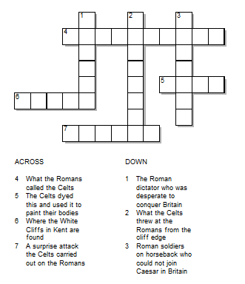

QUESTION 5
Answer these true or false questions about the Roman Empire’s effects on Britain. Circle a response for each one.

- The Romans introduced the Latin alphabet to Britain.

TRUE FALSE

- The Greeks introduced Greek plays to the Britons.

TRUE FALSE

- Celts never attempted to make art before the Romans’ arrival.

TRUE FALSE

- Britain as we know it was shaped by a mixture of many cultures.

TRUE FALSE

ANSWERS

QUESTION 1
The position of Rome on a map is as follows:

QUESTION 2
Citizens of Rome were as follows:

Slaves
Poor men
Rich men
Women

Foreigners

(Poor men and foreigners could win citizenship by serving in the army!)

QUESTION 3
The equipment is named as follows:

Sword
Scutum

Helmet
Pilum

Shield
Gladius

Javelin
Galea

QUESTION 4
The answers to the crossword is as follows:

ACROSS
4. What the Romans called the Celts: Barbarians
5. The Celts dyed this and used it to paint their bodies: Clay
6. Where the White Cliffs are found in Kent: Dover
7. A surprise attack the Celts carried out on the Romans: Ambush

DOWN
1. The Roman dictator who was desperate to conquer Britain: Caesar
2. What the Celts threw at the Romans from the cliff edge: Javelins
3. Roman soldiers on horseback who could not join Caesar in Britain: Cavalry

QUESTION 5
The true or false answers are as follows:
Answer these true or false questions about the Roman Empire’s effects on Britain. Circle a response for each one.

- The Romans introduced the Latin alphabet to Britain.

TRUE FALSE

(The alphabet we still use today!)

- The Greeks introduced Greek plays to the Britons.

TRUE FALSE

(It was the Romans!)

- Celts never attempted to make art before the Romans’ arrival.

TRUE FALSE

(People in Britain had a long history of painting, crafting, and building before the Romans arrived.)

- Britain as we know it was shaped by a mixture of many cultures.

TRUE FALSE

(This was helped by the Romans making Britain part of their Empire – it meant many people travelled and settled in Britain.)

You may be interested in our KS2 History is Easy Revision guide and mock test workbook:
