Vikings Worksheet

QUESTION 1
What are the three countries that make up Scandinavia? Fill in the blanks with letters.
N

E
E
S
R
N
S
Y

QUESTION 2
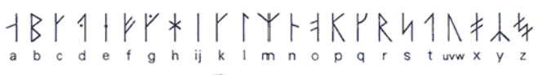
Using the Old Norse alphabet (shown below), translate the message shown on the rune stone into English.
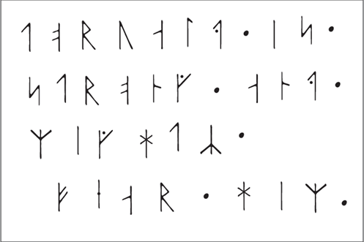
QUESTION 3
Complete the following wordsearch, which focuses on what the Vikings stole during their first raids of Britain.
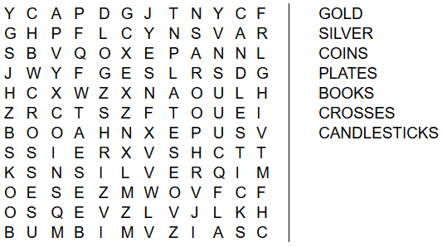

QUESTION 4
Below are three potential definitions of the word ‘Danegeld’. Write ‘A’, ‘B’, or ‘C’ in the box underneath to show which one you think is best.

- Danegeld was the name of the first Viking ship to land on England’s shores.

- Danegeld was the old Viking named for Denmark.

- Danegeld was the idea of paying Viking raiders to stop them attacking, which the Anglo-Saxons tried to do many times.

QUESTION 5
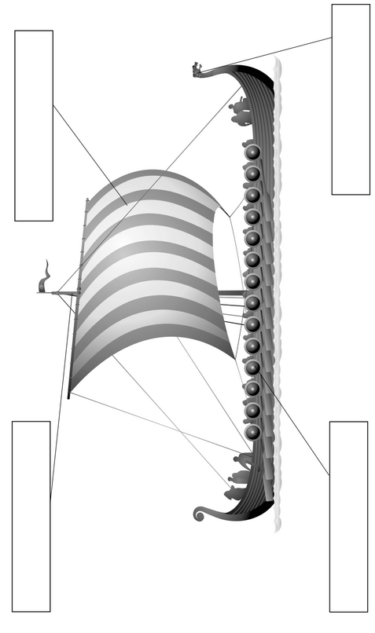
Look at the picture of a Viking longship, and label the different parts of it in the boxes provided.

ANSWERS

QUESTION 1
The countries that make up Scandinavia are as follows:

N
R
A
S
E
K
N
E
M
R
A
N
D
E
D
W
Y
W
O

QUESTION 2
The message reads as follows:
TORVALD IS STRONG AND MIGHTY
FEAR HIM

QUESTION 3
The wordsearch should have been completed as follows:

QUESTION 4
The correct definition for ‘Danegeld’ is ‘C’:

“Danegeld was the idea of paying Viking raiders to stop them attacking, which the Anglo-Saxons tried to do many times.”

QUESTION 5
The longship should have been labelled as follows:

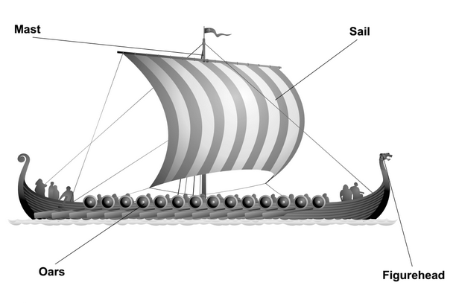

You may be interested in our KS2 History is Easy Revision guide and mock test workbook:

