Working with Numbers
Being comfortable with numbers is vital at this level of French study, as many exam questions will incorporate them, and require the ability to understand and respond accurately using numbers.

1-30
Below are the first 30 numbers written for you in French. Make sure that you have a solid grasp of these numbers – these are very basic and you WILL be required to have a good knowledge regarding numbers.
TOP TIP!
You’ll know these already, but make sure to note when hyphens are used and when they are not.

1 | un | 2 | deux | 3 | trois | 4 | quatre
5 | cinq | 6 | six | 7 | sept | 8 | huit
9 | neuf | 10 | dix | 11 | onze | 12 | douze
13 | treize | 14 | quatorze | 15 | quinze | 16 | seize
17 | dix-sept | 18 | dix-huit | 19 | dix-neuf | 20 | vingt
21 | vingt et un | 22 | vingt-deux | 23 | vingt-trois | 24 | vingt-quatre
25 | vingt-cinq | 26 | vingt-six | 27 | vingt-sept | 28 | vingt-huit
29 | vingt-neuf | 30 | trente

40-100
Now that you have mastered the first 30 numbers in French, let’s take a look at the numbers from 40 to 100.
TOP TIP!
Of course, numbers get more complicated as they get higher. Note when vingt takes an -s and when it does not.

40 - | quarante
50 - | cinquante
60 - | soixante
70 - | soixante-dix | (literally ‘sixty + ten’)
80 - | quatre-vingts | (literally ‘four twenties’)
90 - | quatre-vingt-dix | (literally ‘four twenties + ten’)
100 - | cent

100+
Beyond 100, numbers are nearly always formed using combinations of smaller numbers, although there are some new ones to learn.
TOP TIP!
Note the use of full stops. The French use full stops as opposed to commas! Also note when numbers do and do not take an –s.

101 - | cent un | (not ‘cent et un’)
200 - | deux cents
300 - | trois cents
400 - | quatre cents
500 - | cinq cents
600 - | six cents
700 - | sept cents
800 - | huit cents
900 - | neuf cents
1.000 -  (1,000) | mille
2.000 -  (2,000) | deux mille
1.000.000 -  (1,000,000) | un million
2.000.000 -  (2,000,000) | deux millions
1.000.000.000 -  (1,000,000,000) | un milliard
2.000.000.000 -  (2,000,000,000) | deux milliards

Common ways you’ll have to deal with numbers

So, you’ve learnt what the numbers themselves are, but how will this knowledge be tested? You will need to become adept at recognising when numbers are being discussed, and familiarise yourself with useful common phrases.

Putting things in order
These are pretty straightforward, but be careful using premier/première – this changes when used before something that is masculine/feminine.

NUMBER | FRENCH SPELLING | FRENCH ABBREVIATION
First | premier/première | 1er /1ere
Second | deuxième | 2eme
Third | troisième | 3eme
Fourth | quatrième | 4ème
Fifth | cinquième | 5ème
Sixth | sixième | 6ème
Seventh | septième | 7ème
Eighth | huitième | 8ème
Ninth | neuvième | 9ème
Tenth | dixième | 10ème

Describing groups / approximates of numbers
Note that these sayings are all feminine.

There are about ten (…) | Il y a une dizaine (…)
There are about a dozen (…) | Il y a une douzaine (…)
There are dozens (…) | Il y a des douzaines (…)
There are about a hundred (…) | Il y a une centaine (…)
There are hundreds (…) | Il y a des centaines (…)
There are thousands (…) | Il y a des milliers (…)

Telling the time
Being able to tell the time will be a crucial part of your GCSE French exam. Take a look at the below phrases and see how they translate from French to English.

Asking and responding

Quelle heure est-il? | What time is it?
Il est neuf heures | It is nine o’clock (a.m.)
Il est midi | It is midday
Il est minuit | It is midnight
Il est midi et demi | It is half past twelve (p.m.)
Il est quinze heures dix | It is ten past three (p.m.)
Il est vingt-trois heures et demie | It is half past eleven (p.m.)
À quelle heure est la réunion? | What time is the meeting?
Elle est à treize heures pile | It’s at 1pm sharp
TOP TIP!
Generally, the French tell the time using the 24 hour clock, so saying 6:45 pm is:
Dix-huit heures quarante-cinq

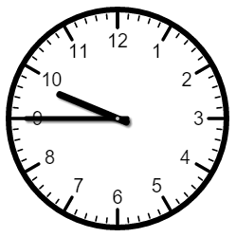

Dix heures moins le quart

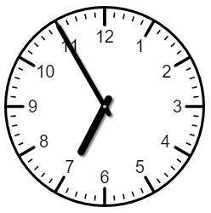

Sept heures moins cinq

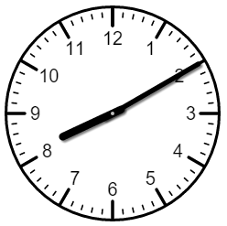

Huit heures dix

TOP TIP!
Expressions like ‘quarter to’, ‘quarter past’ and ‘ten to’ are still used, but only with the 12 hour clock – so be careful!

